**Course11-Colorful water lights**

****Learning goals:****

This lesson learns to use Python programming to light up the water lights of micro:bit smart car.

**Code：**

from microbit import *

import neopixel

display.show(Image.HAPPY)

# The water lamp is connected to pin pin16, the number is 3

np = neopixel.NeoPixel(pin16, 3)

# iterate each LED in the water lights

for pixel_id in range(0, len(np)):

# Light up the first water light to red

np[0] = (255, 0, 0)

# display color

np.show()

In the program, import neopixel is means to import neopixel library, we can make micro:bit robot display a smile on the lattice. Then define the pin of the water light as pin16, the number is 3, iterate each LED in the water lights., np[0] = (255, 0, 0) means that the first water light is red. Modify the parameters in the brackets to change the color of the light.

**Programming and downloading：**

1. You should open the Mu software, and enter the code in the edit window, , as shown in Figure 11-1.

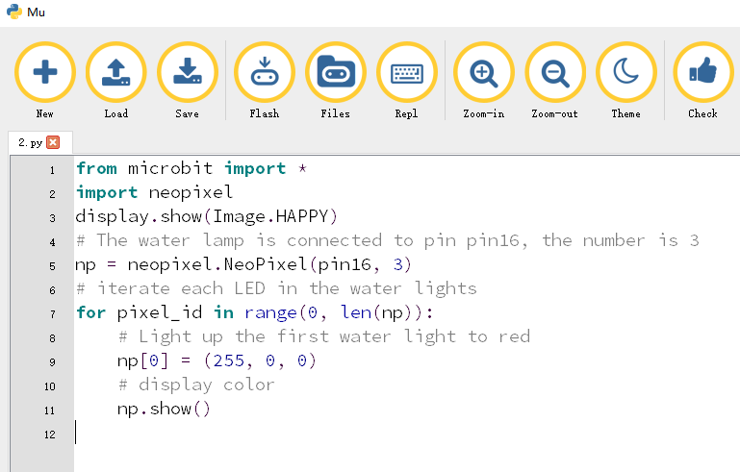

Figure11-1

2.As shown in Figure 11-2, you need to click the Check button to check if our code has an error. If a line appears with a cursor or an underscore, the program indicating this line is wrong.

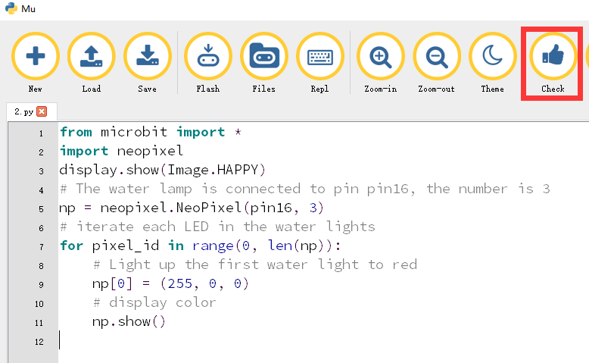

Figure 11-2

3.You need to connect the micro data cable to micro:bit and the computer, then click the Flash button to download the program to micro:bit as shown in Figure 11-3.

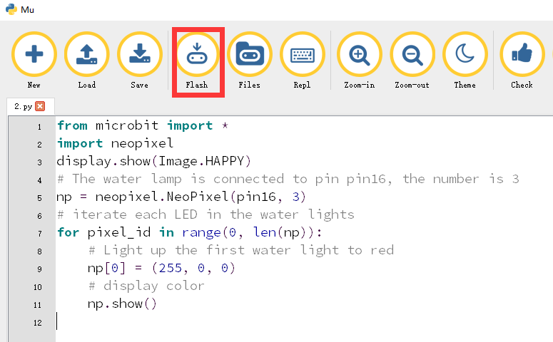

Figure 11-3

4. The schematic diagram of the flow lamp of the robot is shown in Figure 11-4. As you can see, the flow light of the robot is connected to the pin16 of the micro:bit. Therefore, we set the pin of the flow lamp to pin16 in the program. After downloading the program to micro:bit, you can see a smile on the dot matrix of the robot as shown in Figure 11-5, and light the first water light to red.

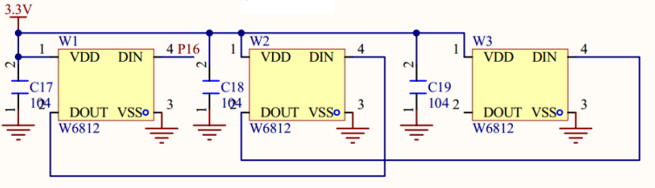

Figure 11-4

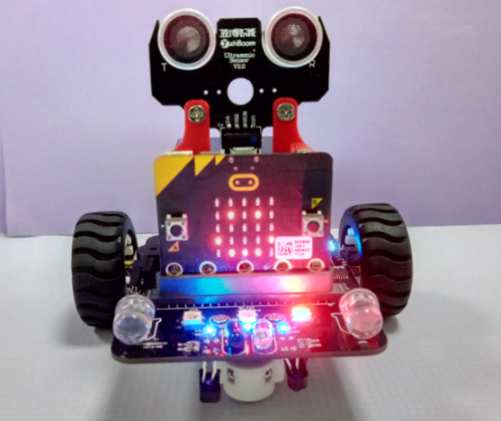

Figure 11-5